**Exercise 1:** Suppose we have a computer that contains a folder called “tutorials” with “Full control” permissions for the standard users. We want to share the folder with “Read-only” permissions. It is necessary for the other computers’ users to log in with a password.

Explain the steps needed to complete the process and the permissions we must grant in order to access the “tutorials” folder through the network. Specify the address to access the folder from the computers.

---

First we need to turn on network discovery. This can be set in “Network and Sharing Center” in “Advanced sharing settings”

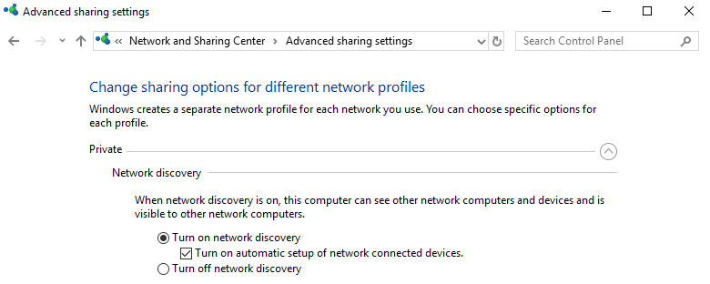

To make other users login with a password, we need to enable “Password protected sharing” too. 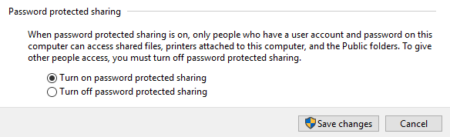

Once done that, we will create the folder required and set the local permissions (Properties → Security → Advanced):

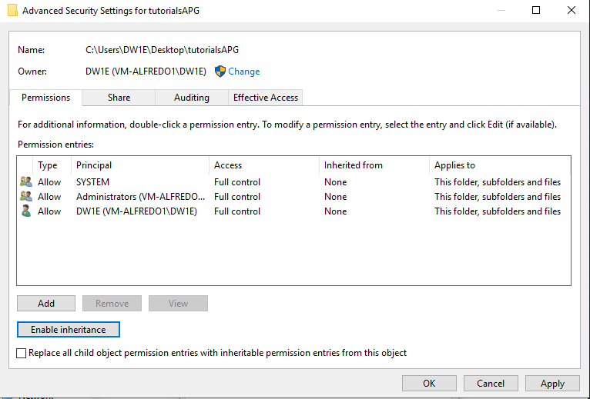

In my case I disable inheritance. Make sure the standard users have full control.

Now we need to set the sharing permissions. This will be done after enabling the sharing option (Properties → Sharing → Advanced Sharing)

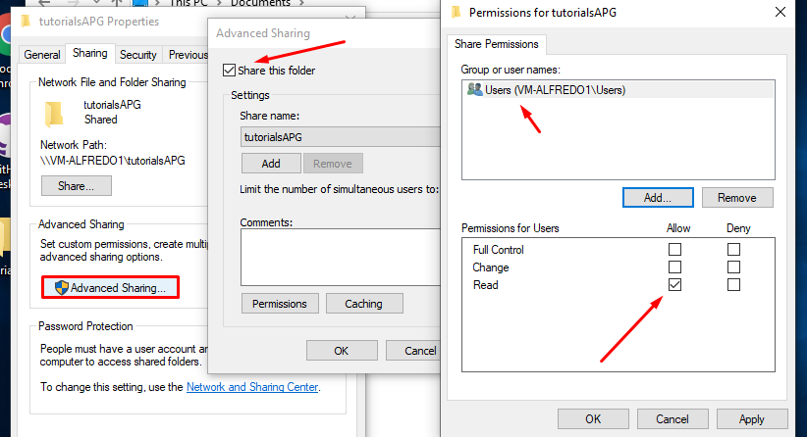

After that, we will click on “Permissions” and give “Users” only reading permissions.

Finally, when trying to connect **from another computer** (virtual machine in this case), this pop-up appears:

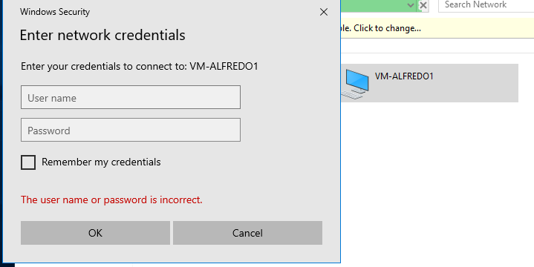

**ALFREDO PUERTA GALLEGO DW1E**